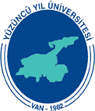

International Congress of 21st Century Islamic World: A Strategic Perspective (Opportunities, Possibilities, Developments, Challenges, Solution Proposals)
(11-13 May 2017)

Name and surname
Country:
Institution:
Abstract (Presentation Title)
Abstract (Title of the Presentation)

