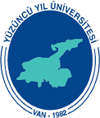

International Congress of 21st Century Islamic World: A Strategic Perspective (Opportunities, Possibilities, Developments, Challenges, Solution Proposals)
(11-13 May 2017)

DEADLINE FOR THE SUBMISSION OF THE ABSTRACTS: 15-February-2017
Name and surname
Country:
Institution:
Title of Presentation
Abstract:

Key Words:
NOTE: 1- Participants can attach a Turkish abstract together with the English abstract, too, if they wish
2-A maximum of 300 world words must be written for the abstracts

